CO2-AT2
SCENARIO-BASED ASSESMENT

NAME : S.PON SURYA
REG NO : 192411145

SOURCE CODE
Q26)def linear_search(order_ids, target):
comparisons = 0

for i in range(len(order_ids)):
comparisons += 1

if order_ids[i] == target:
return i, comparisons

return -1, comparisons

print("==============================================")
print("E-COMMERCE ORDER RETRIEVAL SYSTEM")
print("==============================================")

# Unsorted order IDs
order_ids = [1052, 1007, 1034, 1012, 1089, 1045, 1023]

target = int(input("Enter Order ID to search: "))

position, comparisons = linear_search(order_ids, target)

print("\nOrder IDs:", order_ids)

if position != -1:
print("Order Found!")
print("Position:", position + 1)
print("Comparisons:", comparisons)
else:
print("Order Not Found!")
print("Comparisons:", comparisons)

print("\nTime Complexity:")
print("Best Case : O(1)")
print("Average Case: O(n)")
print("Worst Case : O(n)")

REPORT
Title
Performance Analysis and Improvement of Linear Search in an E-Commerce Order Management System
Aim
To implement Linear Search for retrieving order IDs from an unsorted e-commerce order database, analyze its performance as the number of orders increases, and suggest suitable improvements for efficient order retrieval.
Problem Statement
An e-commerce system stores order IDs in an unsorted list because new transactions are continuously added.
The system uses Linear Search to retrieve a particular order ID.
The objectives are:
- Explain how Linear Search operates on unsorted order IDs.
- Analyze the performance degradation as the number of orders increases.
- Suggest suitable improvements and justify the selected solution.
Application Background
In an e-commerce system, orders are continuously generated.
For example, the order IDs may be stored as:
[1052, 1007, 1034, 1012, 1089, 1045, 1023]
Since the order IDs are not sorted, the system cannot directly use binary search.
When a customer requests an order, Linear Search checks each order ID sequentially until the required ID is found.
For example, searching for:
1089
requires checking:
1052 → 1007 → 1034 → 1012 → 1089
The required order is found at the fifth position.
Algorithm
START

Read the list of order IDs
Read the target order ID

FOR each order ID in the list
Compare order ID with target
IF order ID == target
Display "Order Found"
Display position
STOP
END IF
END FOR

Display "Order Not Found"

STOP
OUTPUT
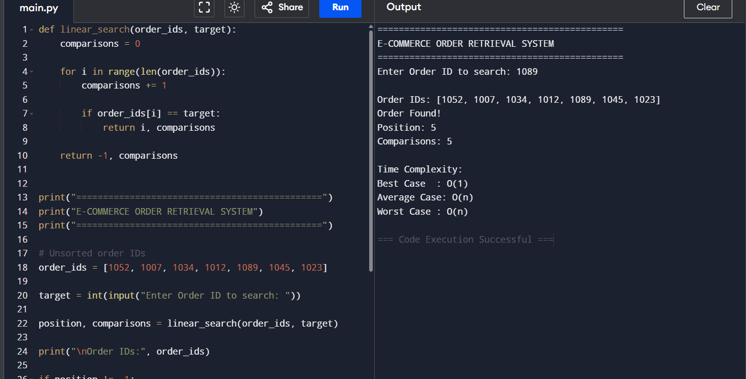
Output Analysis
The program searches for the order ID 1089 in the unsorted order list:
[1052, 1007, 1034, 1012, 1089, 1045, 1023]
Linear Search checks each order ID sequentially:
1052 → 1007 → 1034 → 1012 → 1089
The target 1089 is found at position 5, so the algorithm performs 5 comparisons.
The output confirms that Linear Search successfully retrieves an order from an unsorted list.
Time Complexity Analysis
Case | Situation | Complexity
Best Case | Target is the first element | O(1)
Average Case | Target is somewhere in the middle | O(n)
Worst Case | Target is last or not present | O(n)
Best Case
If the required order is the first element, only one comparison is required:
Average Case
On average, approximately half of the order IDs need to be checked:
Ignoring constants:
Worst Case
If the order is at the end or does not exist, every order ID must be checked:
Performance Degradation
As the number of orders increases, the number of comparisons also increases.
Orders | Average Comparisons | Worst Comparisons
100 | ~50 | 100
1,000 | ~500 | 1,000
10,000 | ~5,000 | 10,000
100,000 | ~50,000 | 100,000
Therefore, Linear Search becomes slower as the e-commerce database grows.
Improvement Analysis
For a continuously growing e-commerce system, Hash Table/Dictionary is a better choice because it provides approximately:
average search time.
Another option is Binary Search, which provides:
but requires the order IDs to be maintained in sorted order.
Final Decision
Since the e-commerce system receives continuous transactions, a Hash Table is recommended. It supports fast searching and dynamic insertion without requiring the entire order list to remain sorted.
Conclusion
Linear Search works correctly for unsorted order IDs, but its O(n) average and worst-case complexity causes performance degradation for large datasets. Hash-based indexing provides a more scalable solution for large e-commerce order retrieval systems.

